# Lab 1: Web Server Setup

Contents

Lab 1: Web Server Setup 1

Local Server 2

AWS 2

Azure 3

W3Schools 3

Analysis 4

What parts of the process went right**:** 4

The challenges you faced and what went wrong 4

What you need to learn more about concerning web server setup and usage 4

# Local Server

Link: <http://127.0.0.1:5500/>

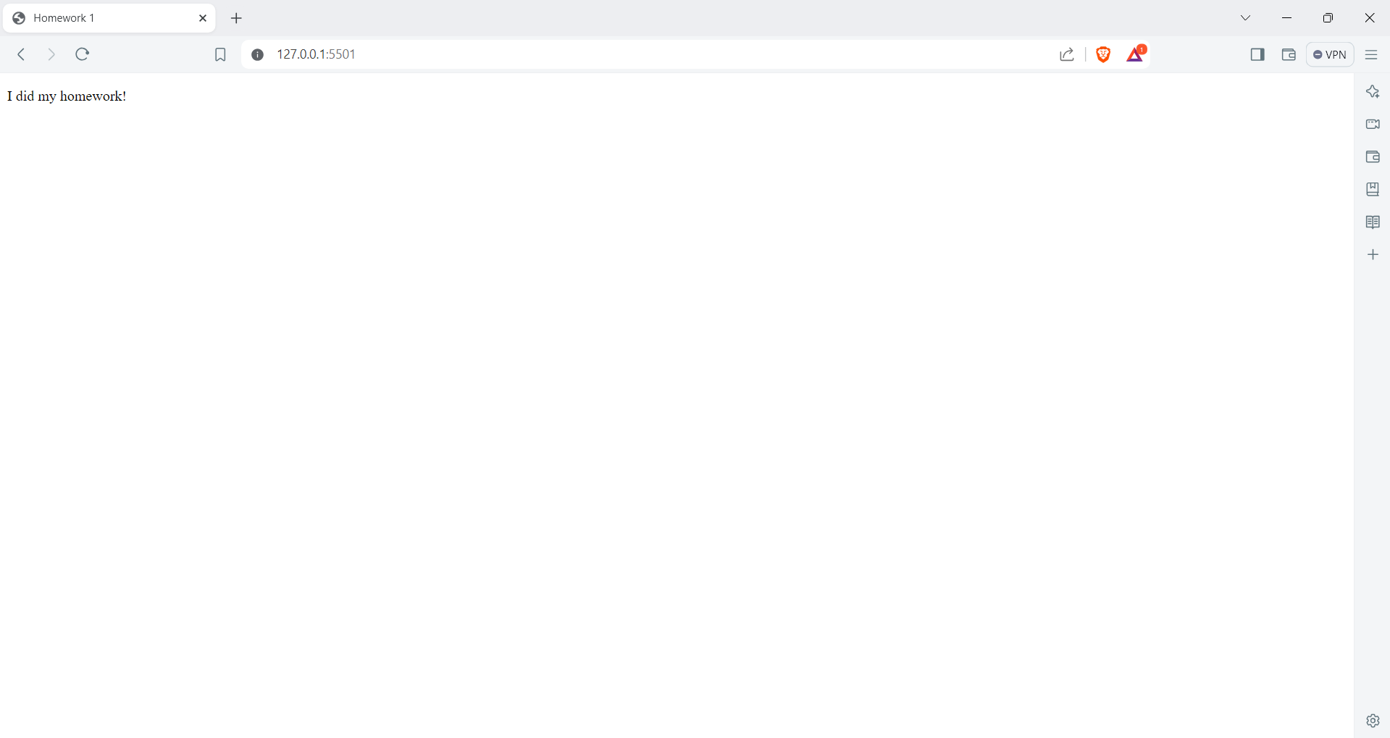

# AWS

Link: <http://ec2-3-110-88-52.ap-south-1.compute.amazonaws.com/>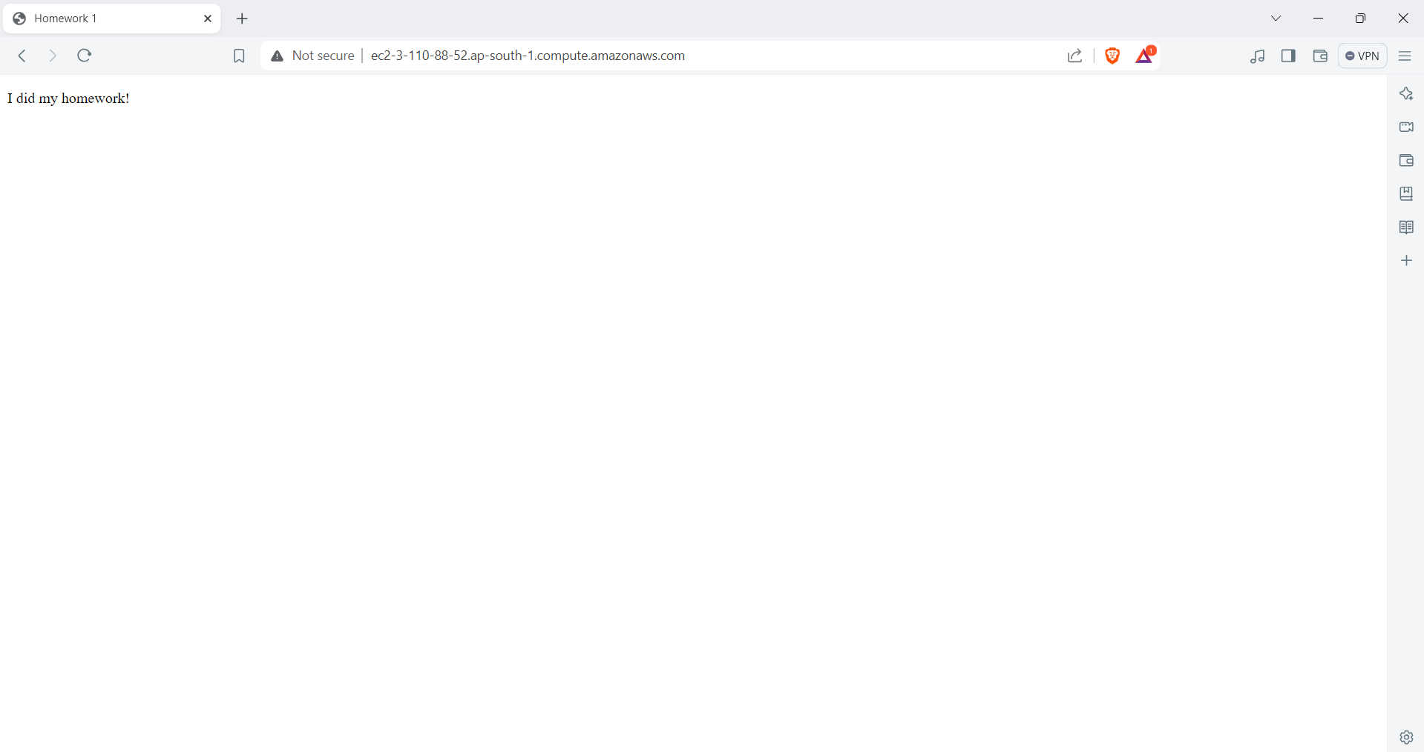

# Azure

Link: [https://polite-forest-048893e0f.5.azurestaticapps.net/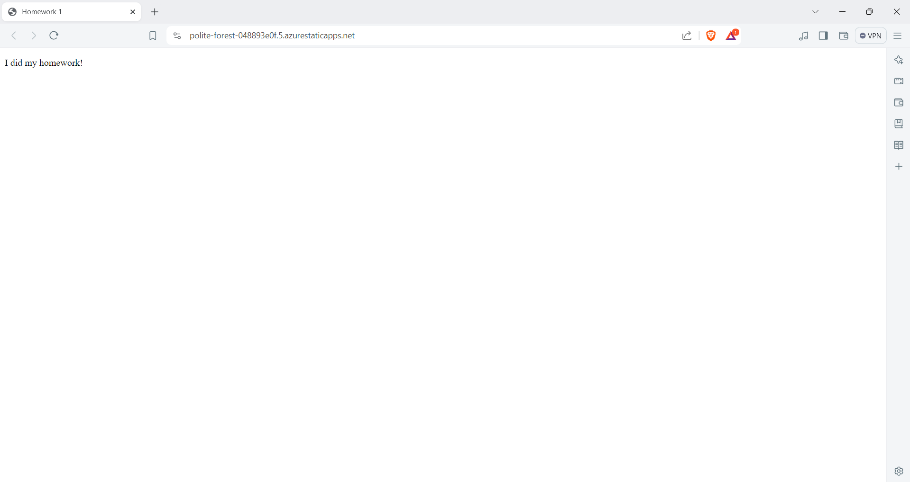](https://polite-forest-048893e0f.5.azurestaticapps.net/)

## W3Schools

Link: <https://eshwar-itc-505.w3spaces.com/>

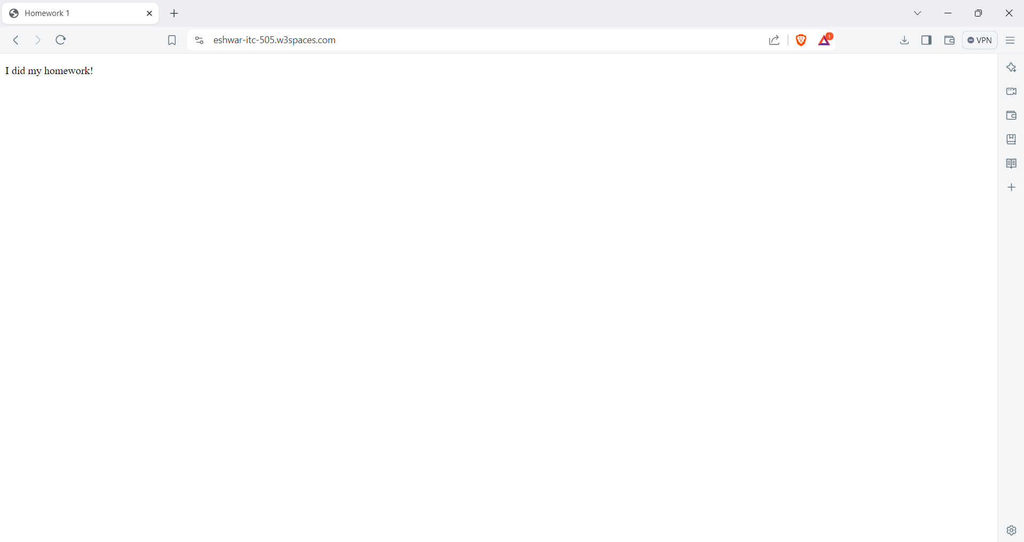

# Analysis

## What parts of the process went right**:**

* **Local Webserver:** Setting up a local server was easy. My webpage popped right up in the browser!
* **AWS:** Launching an Amazon server wasn't too bad either. I followed the guide as mentioned in the video, set up security, and got my webpage running.
* **Azure:** Azure's Static Web Apps were awesome. They hooked up with GitHub to automatically deploy my webpage whenever I made changes. Super convenient!
* **W3Schools Hosting:** Uploading my webpage to W3Schools was simple. Their interface was clear, and my site was up and running in no time.

## The challenges you faced and what went wrong

* **Local Webserver:** No problems here!
* **AWS:** Security groups were the main hurdle. My webpage wasn't showing up at first because it was not working with https, I used http to get my webapp up and running.
* **Azure:** The account creation process was little bit long, I had to create a new account and then use it in the visual studio code. It was hard to find the Static Web Apps extension at first.
* **W3Schools Hosting:** Figuring out their file system was a bit tough. I had to make sure my files were organized just right for the webpage to work.

## What you need to learn more about concerning web server setup and usage

* **File Structure Matters:** Keeping your web project files organized is super important. If things are in the wrong folders, your webpage won't work.
* **Security is Key:** On platforms like AWS, you need to set up security correctly so people can see your webpage, but also to keep it safe.
* **Automation is Awesome:** Learning tools like GitHub Actions can help you deploy webpages automatically, which saves time.
* **Explore Your Options:** Trying out different hosting platforms like W3Schools shows you the different ways you can deploy webpages.